**MIPS #508**

**Covid-19 Vax**

Percentage of patients who are up to date on their Covid-19 vaccination(s).

* Review the patient’s medical record to find vaccination history related to Covid-19. This can be found in various areas such as…
  + H&P
  + PCC under immunizations
  + Hospital records
* Under the ChartPath PMH section, document the pt having received the Covid-19 vaccine

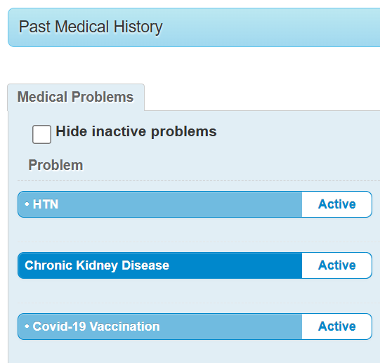

Up to date = at least 2 doses of any Covid-19 vaccine

M1417

Click if patient is up to date on Covid-19 vaccination(s)

Click if not up to date due to a documented medical contraindication

M1418