**MIPS #326**

**A-Fib, A-Flutter and Anticoagulation**

Percentage of patients with atrial fibrillation (AF) or atrial flutter who were prescribed an FDA-approved oral anticoagulant drug

* Review the patient’s Medical Diagnosis list
* Document on the **LAST PAGE** of your note in **YOUR DIAGNOSIS** section one or more of the following codes for Afib:
  + I48.0, I48.3, I48.4, I48.11, I48.19, I48.20, I48.21, I48.91, I48.92

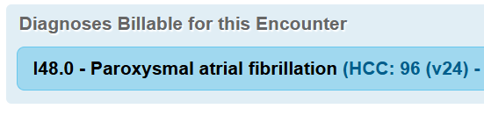

* Document in the Medication section if patient is being prescribed an anticoagulant medication:
  + Coumadin/Jantoven(warfarin sodium)
  + Apixaban / Eliquis
  + Dabigatran / Pradaxa
  + Edoxaban / Lixiana
  + Rivaroxaban / Xarelto
  + Warfarin / Coumadin

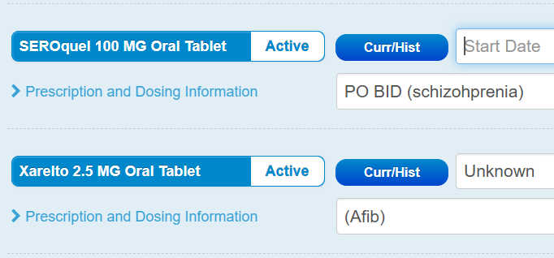

G8967

Click if patient is prescribed an FDA-approved oral anticoagulant

Click if documented medical reason(s) for not prescribing an FDA-approved anticoagulant

G8968