**MIPS #243**

**Cardiac**

Patients who had an MI, CABG, or other cardiac event within the last 12 months who were then referred to an outpatient cardiac rehab program

* Review the patient’s Medical Diagnosis list or medical team progress notes
* 1) Be sure to carry over into your PMH one or more of the following codes/diagnoses for cardiac issues:
  + Angina
    - I20.1, I20.2, I20.81, I20.89, I20.9, I25.112, I25.702, I25.712, I25.722, I25.732, I25.752, I25.762, I25.792
  + Myocardial Infarction
    - I21.01, I21.02, I21.09, I21.11, I21.19, I21.21, I21.29, I21.3, I21.4, I21.9, I21.A9, I21.B, I22.0, I22.1, I22.2, I22.8, I22.9, I25.2
  + CABG
  + Percutaneous Coronary Inventory
  + Cardiac Valve Surgery
  + Cardiac Transplant
  + Cardiac Event
* 2) Document in your Assessment/Plan, the following 2 elements
  + Pt has had communication with a healthcare provider about outpatient follow up related to their cardiac issues.
  + Document the referral order or, if not done by you, upload the order by another provider

*(****Example*** of finding a follow up on hospital paperwork to be uploaded into ChartPath)

*(****Example*** of documenting communication about outpatient follow up)

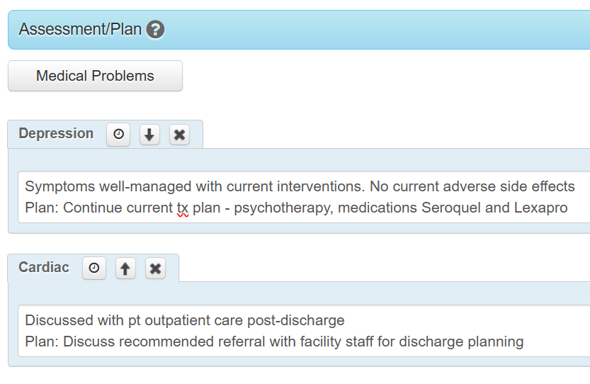

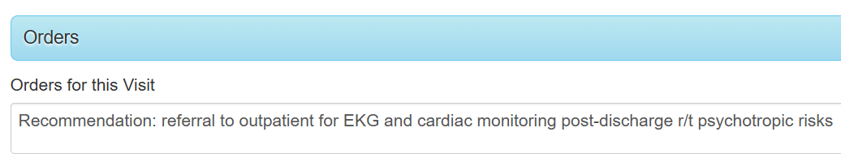

* 3) **Manually** enter the applicable MIPS codes into the Billing section of your ChartPath note



Enter if patient referred to outpatient cardiac program

4500F

Enter with if doc medical reason (too medically unstable for outpt)

1P

4500F

2P

Enter with if doc pt reason for not referring (pt declined referral)

4500F

Enter if pt had previous cardiac rehab for the most recent cardiac event

4510F