**MIPS #383**

**Adherence for Antipsychotic for Schizophrenia**

Individuals with schizophrenia or schizoaffective disorder who had at least two prescriptions renewed or had consistent orders for antipsychotic medications over the course of approximately 12 months

* Click the Index date for the first known date the patient was ordered/prescribed antipsychotic(s) medications for this current year.
  + *Use the first day in Jan 2025 that you saw the patient and confirmed antipsychotic orders*
* Also document the date in the Medication section

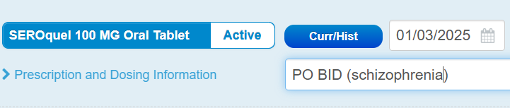

Near the end of the performance period confirm the patient had consistent orders to cover at least 80% or more of the annual measurement period

At the end of this year…

Select if patient had orders for the antipsychotic(s) to cover 80% of this year

G9512