MIPS #286
Dementia: Safety Concern Screening and Follow-Up
- The provider MUST document screening for safety concerns in 2 domains of risk: Danger to self or others AND Environmental risks.

- To fully meet the measure, you have documentation of screening on at least one concern for each domain
  - Dangerousness to self or others
    - Medication misuse
    - Physical aggression
    - Wandering
  - Environmental risks examples
    - Access to firearms
    - Trip hazards
    - Access to dangerous chemicals
- If the safety concerns were positive, you MUST document mitigation recommendations and discuss with patient and caregivers (ex. referral to other resources)

Examples
Example of documenting dangerousness to self/others: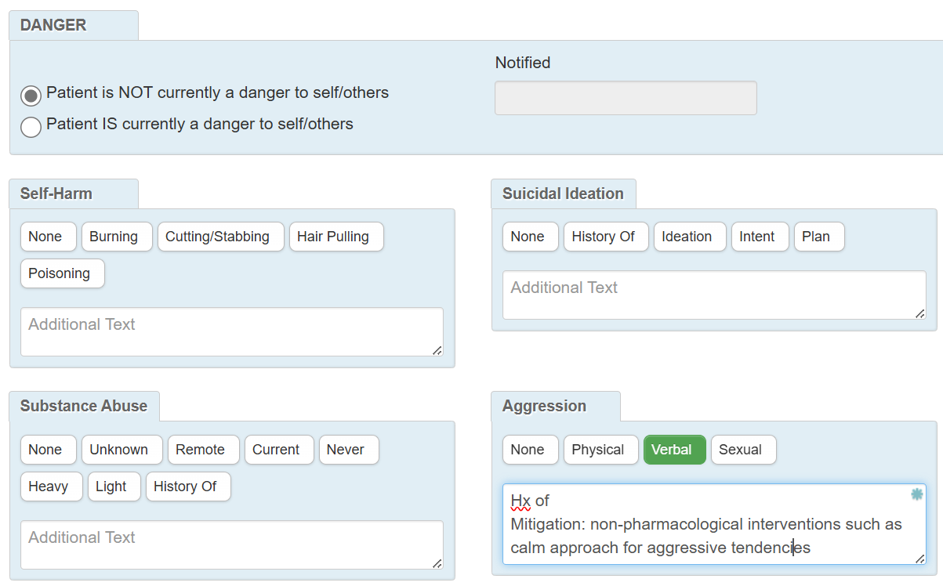
Example of documenting environmental risk:
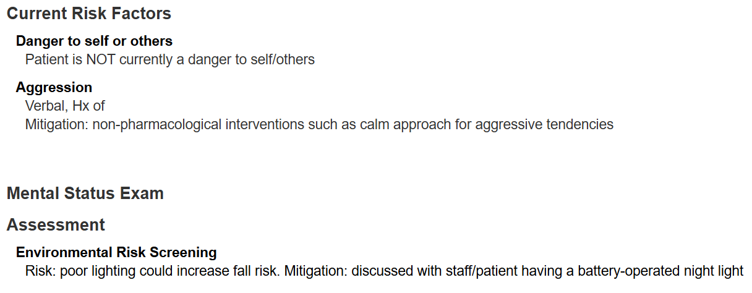
Examples

Example of documenting dangerousness to self/others:
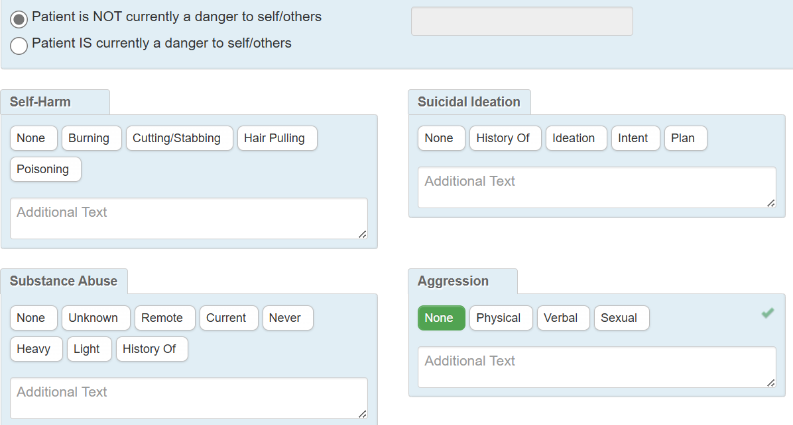

Example of documenting environmental risk:
