**MIPS #290**

**Mood Disorders and Psychosis in Parkinson’s**

* Completed for all patients diagnosed with Parkinson’s Disease (be sure you are coding the G20 dx)
* You MUST assess ALL of the following:
  + Depression
  + Anxiety
  + Apathy
  + Psychosis

**Instructions**

Your documentation will need to cover when the symptom is present and when it is not. In other words, leaving an area blank would not show you indeed assessed the item.

You have several options to do this:

1. Select the bubble in the mental status section when the symptom is present
2. If the symptom is not present, use the additional text box to show you assessed but it was negative

OR

1. Use the Assessment Type box and the Score box to indicate whether or not the symptoms were present

**MIPS #291**

**Cognition in Parkinson’s**

* Completed for all patients diagnosed with Parkinson’s Disease
* MUST use one of these approved tools:
  + Mini-Mental Status Examination (MMSE)
  + Montreal Cognitive Assessment (MoCA)

**Instructions**

1. Use the Assessment Type box and the Score box to indicate the tool used and score
2. If the patient was unable to be assessed, document the reason in the Score box (declined assessment, patient not able to complete due to severe symptoms, non-verbal, etc.)

**Examples**

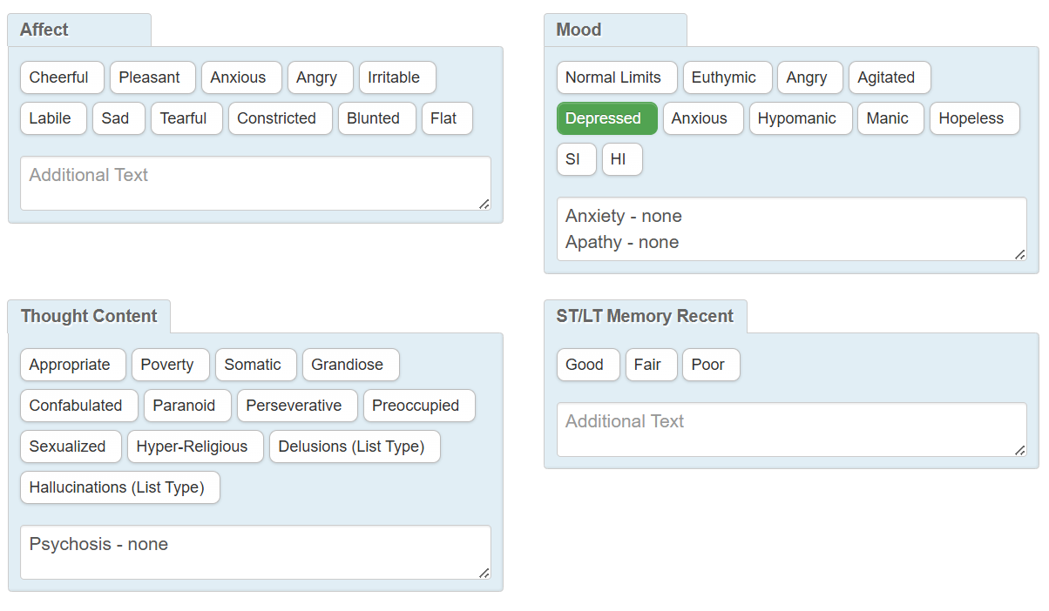

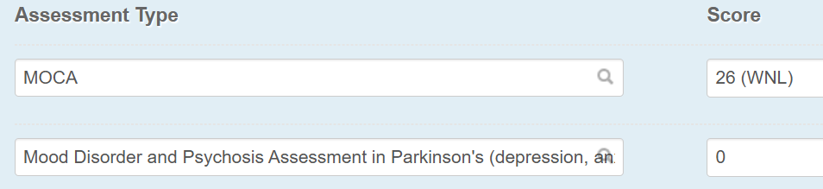

= Cognitive screening tool completed

3720F

= Declined assessment

G0036

= Patient not able to participate and no knowledgeable informant is available

G0037