MIPS #383
Adherence for Antipsychotic for Schizophrenia

Individuals with schizophrenia or schizoaffective disorder who had at least two prescriptions renewed or had consistent orders for antipsychotic medications over the course of approximately 12 months

- In the preferred date box, enter the first known date the patient was ordered/prescribed antipsychotic(s) medications for this current year. (This is also known as the Index Date)
  - Use the first day in Jan 2026 if the patient has been sustained on their antipsychotic from the previous year

- Also document the date in the Medication section

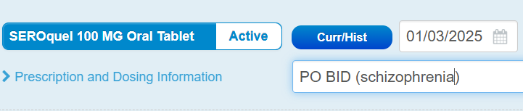

- After 2 prescriptions of their antipsychotic being filled (i.e. in SNFs, meds are automatically refilled monthly), enter the code M1380 in the Procedure CPT Code box at the end of your note.
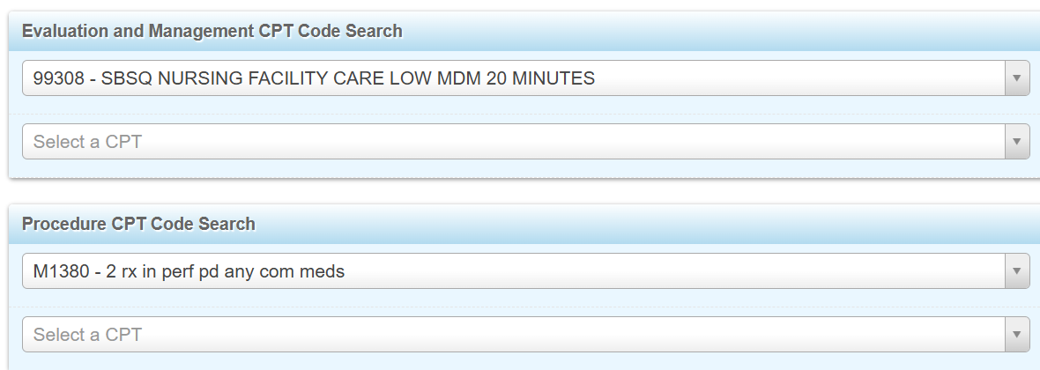

- At the end of this year…

Select if patient had orders for the antipsychotic(s) to cover 80% of this year
G9512

