MIPS #431
Unhealthy Alcohol Use
Requires all adults be screened for alcohol use, excludes those with Dementia
- Screen for unhealthy alcohol use using the approved screening method listed below:
  - Single Question Screening: “How many times in the past year have you had 5 (for men) or 4 (for women and adults age 65+) or more drinks in a day?”
- Brief counseling = one or more counseling sessions a minimum of 5-15 minutes

Example of documenting use of a systematic screening of Alcohol using the Single Question tool: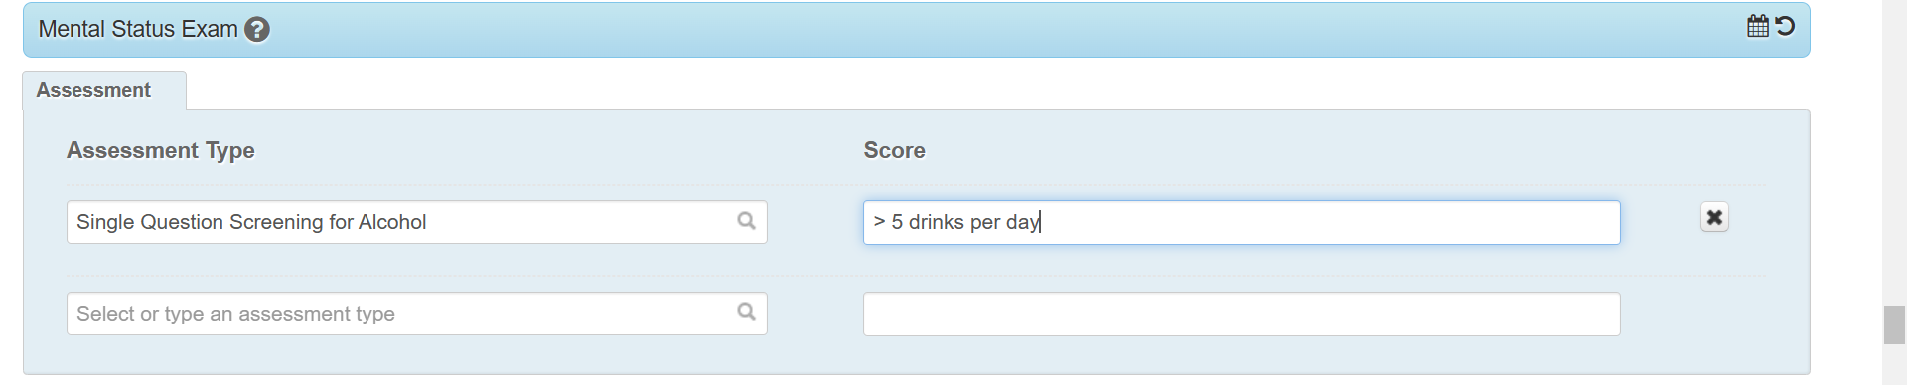
G2196
Click if you asked the patient how many times they have drank and it was more than 5 (men) or 4 (women)

Click if you screened the patient and they did not meet the criteria for unhealthy drinking
G2197
G2200
Click if you did the screen question, patient scored as an unhealthy alcohol user, and you provided counseling

After patient has been seen for at least two visits….
G9621
Click if you did the screen question, patient scored as an unhealthy alcohol user, and you provided counseling

*The CAGE-AID is a great tool and should continue to be used, but you MUST also include the Single Question Screening

