MIPS #243
Cardiac

Patients who had an MI, CABG, or other cardiac event within the last 12 months who were then referred to an outpatient cardiac rehab program

- Review the patient’s Medical Diagnosis list or medical team progress notes

- 1) Be sure to carry over the appropriate cardiac issue into your diagnosis list on the last page of your note:
  - Angina
    - I20.1, I20.2, I20.81, I20.89, I20.9, I25.112, I25.702, I25.712, I25.722, I25.732, I25.752, I25.762, I25.792
  - Myocardial Infarction
    - I21.01, I21.02, I21.09, I21.11, I21.19, I21.21, I21.29, I21.3, I21.4, I21.9, I21.A9, I21.B, I22.0, I22.1, I22.2, I22.8, I22.9, I25.2
  - CABG
  - Percutaneous Coronary Inventory
  - Cardiac Valve Surgery
  - Cardiac Transplant
  - Cardiac Event

- 2) Document in your Assessment/Plan, the following 2 elements
  - Pt has had communication with a healthcare provider about outpatient follow up related to their cardiac issues.
  - Document the referral order or, if not done by you, upload the order by another provider

(Example of finding a follow up on hospital paperwork to be uploaded into ChartPath)

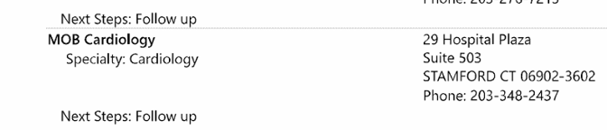

(Example of documenting communication about outpatient follow up)
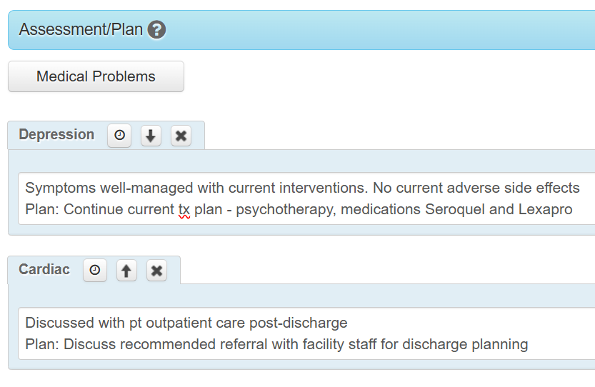
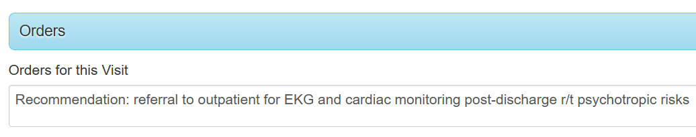

- 3) Manually enter 1460F AND the applicable MIPS codes into the Billing section of your ChartPath note

Enter if patient referred to outpatient cardiac program
4500F

Enter with if doc medical reason (too medically unstable for outpt)
1P
4500F
2P
Enter with if doc pt reason for not referring (pt declined referral)
4500F

Enter if pt had previous cardiac rehab for the most recent cardiac event
4510F

